Log Management
https://docs.datadoghq.com/logs/
Datadog Log Management, also referred to as Datadog logs or logging, removes these limitations by decoupling log ingestion from indexing. This enables you to cost-effectively collect, process, archive, explore, and monitor all of your logs without limitations, also known as Logging without Limits*.
Logging without Limits* enables a streamlined troubleshooting experience in the Log Explorer, which empowers you and your teams to quickly assess and fix your infrastructure issues. It provides intuitive archiving to support your security and IT teams during audits and assessments. Logging without Limits* also powers Datadog Cloud SIEM, which detects security threats in your environment, without requiring you to index logs.
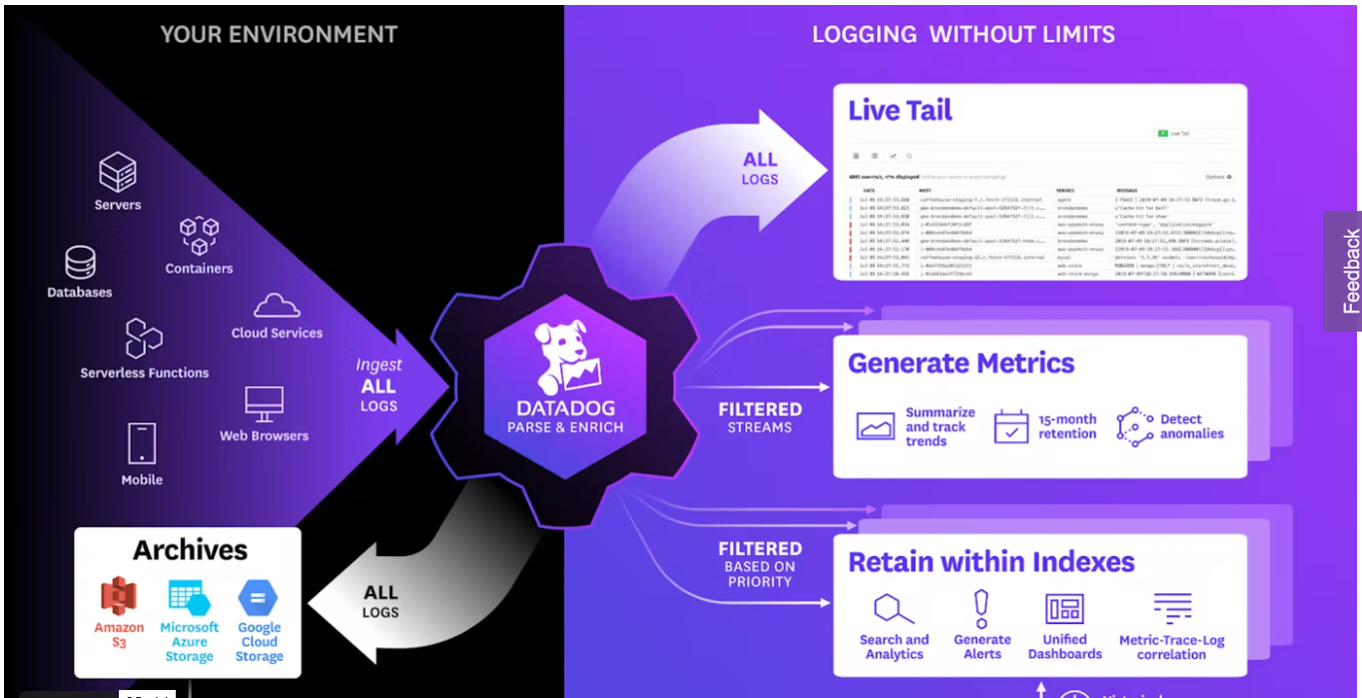

https://www.datadoghq.com/videos/advances-in-log-management/

Centralized Processing + Nested Pipeline + Standard Attributes

https://www.datadoghq.com/videos/dash-keynote-logging-without-limits/

Ingest , Process & Live Tail all your logs
Archive to the storage of your choice
Dynamically choose what to retain and index

https://docs.datadoghq.com/logs/log_collection/csharp/?tab=serilog
https://medium.com/geekculture/pushing-your-logs-to-datadog-through-serilog-sink-77f0f26de53

